SAAS-BASED CAR BOOKING SYSTEM (SAAS ON ZOHO CREATOR)

Name:JAGADEESH A

Reg no:192521294
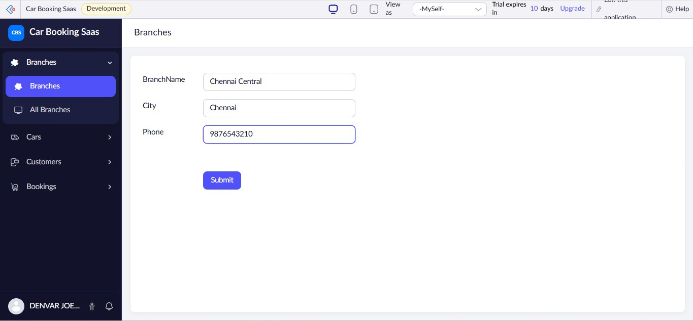
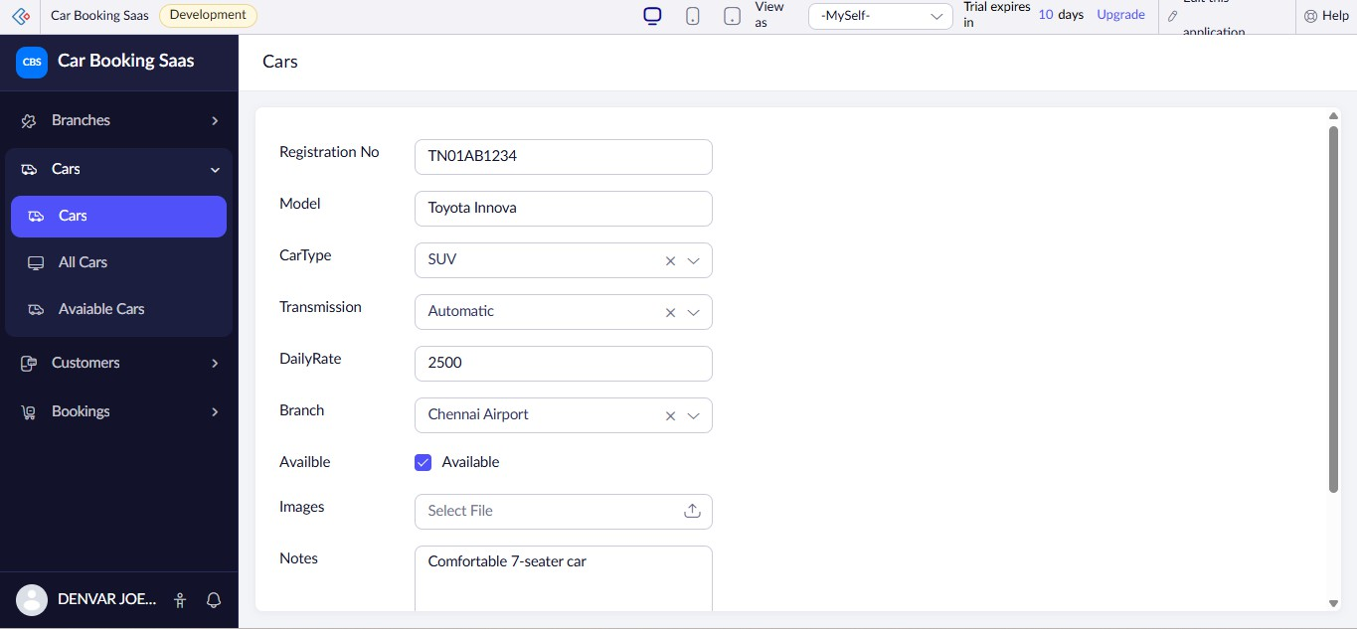

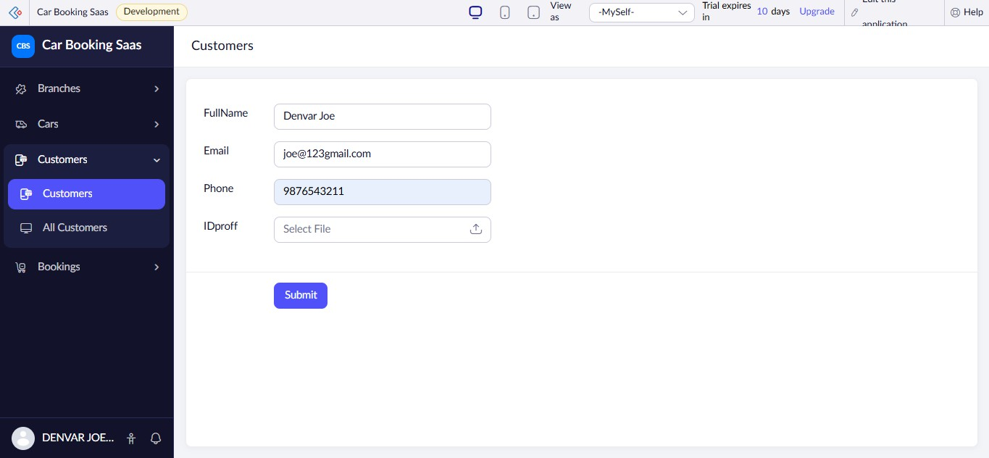
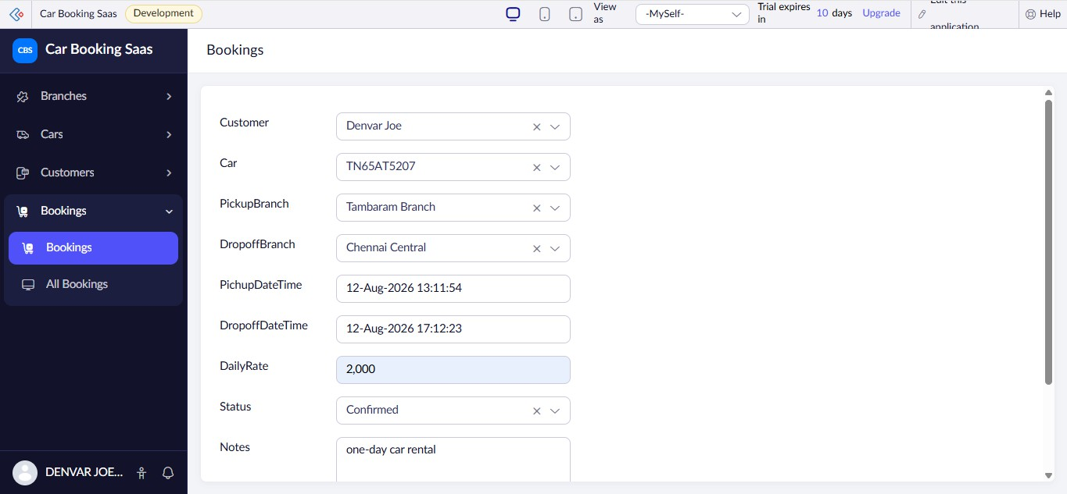

All Branches
BranchName
City

BranchID | BranchName City |  | Phone
3 | Tambaram Branch | Chennai | 9876543212
2 | Chennai Airport | Chennai | 9876543211
1 | Chennai Central | Chennai | 9876543210

All Cars
Registration No
Model
CarType
Transmission
DailyRate

CarID | Registration No | Model | CarType | Transmission | DailyRate | Branch
3 | TN03GS8907 | Nissan | Sedan | Manual | ₹ 1,800.00 | Chennai Central
2 | TN65AT5207 | Hyundai Creta | SUV | Manual | ₹ 2,000.00 | Tambaram Branch
1 | TN01AB1234 | Toyoto Innova | SUV | Automatic | ₹ 2,500.00 | Chennai Airport

All Customers
FullName
Email
Phone

CustomerID | FullName Email Phone |  |  | IDproff
3 | Arun Kumar | kumar@gmail.com | 9876543211
2 | joal | joal@gmail.com | 9876543212
1 | Denvar Joe | joe@123gmail.com | 9876543211

All Bookings
Customer
Car
PickupBranch
DropoffBranch
PichupDateTime

BookingID | Customer | Car | PickupBranch | DropoffBranch | PichupDateTime | DropoffDateTime
3 | joal | TN01AB1234 | Chennai Central | Chennai Airport | 13-Aug-2026 14:15:13 | 15-Aug-2026 14:15:17
2 | Arun Kumar | TN03GS8907 | Chennai Airport | Tambaram Branch | 13-Aug-2026 14:14:24 | 13-Aug-2026 17:14:27
1 | Denvar Joe | TN65AT5207 | Tambaram Branch | Chennai Central | 12-Aug-2026 13:11:54 | 12-Aug-2026 17:12:23

